1.Implement data frames in R. Write a program to join columns and rows in a data frame using c bind()and r bind() in R.

Output:

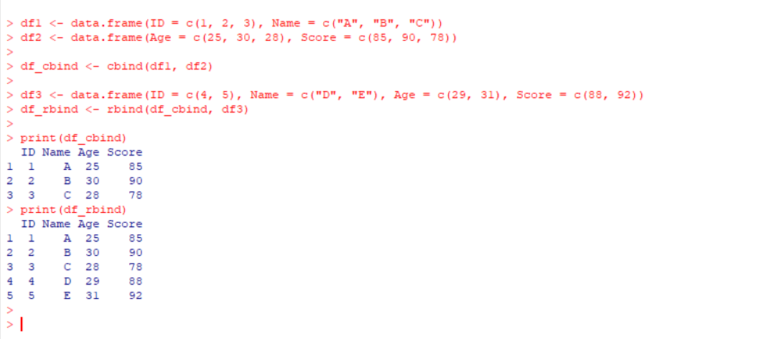

2. Implement different String Manipulation functions in R.

Output:

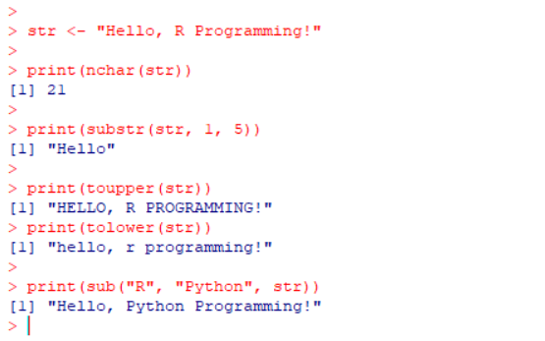

3. Write R program to find Correlation and Covariance and Write R program for Regression Modeling.

Output:

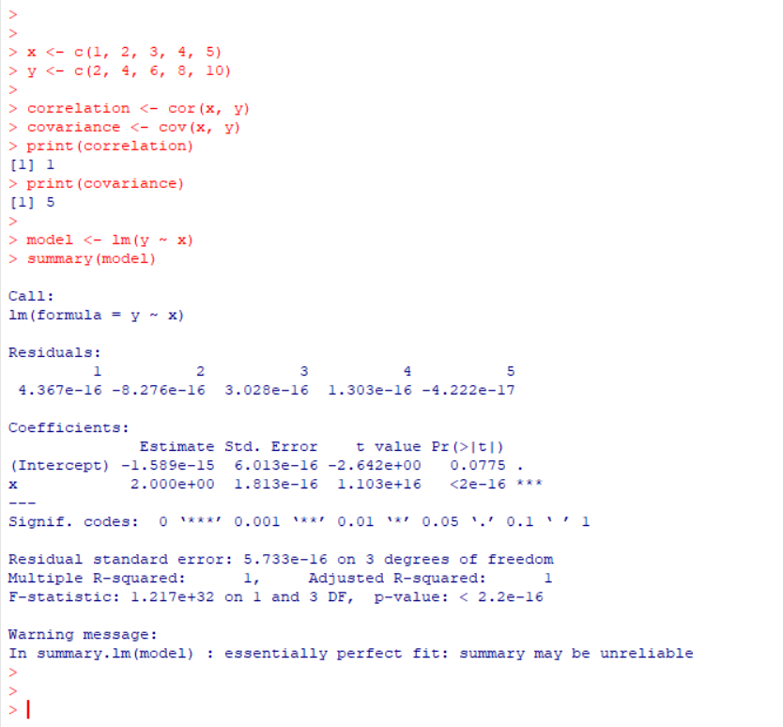

4.Write R program to build classification model using KNN algorithm.

Output:

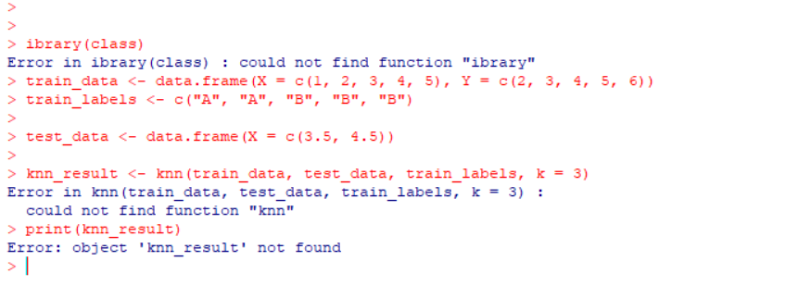

5. Write R program to build clustering model using K-mean algorithm.

Output:

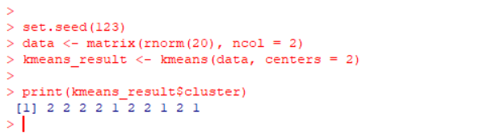

6.Write a R program to create three vectors numeric data, character data and logical data. Display the content of the vectors and their type.

Output:

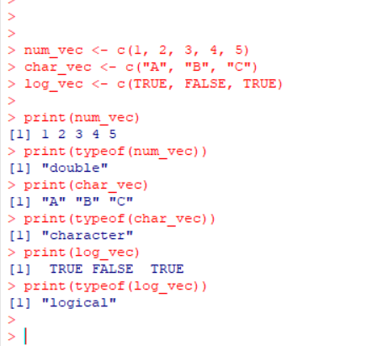

7.Write a R program to create a 5 x 4 matrix , 3 x 3 matrix with labels and fill the matrix by rows and 2 × 2 matrix with labels and fill the matrix by columns.

Output:

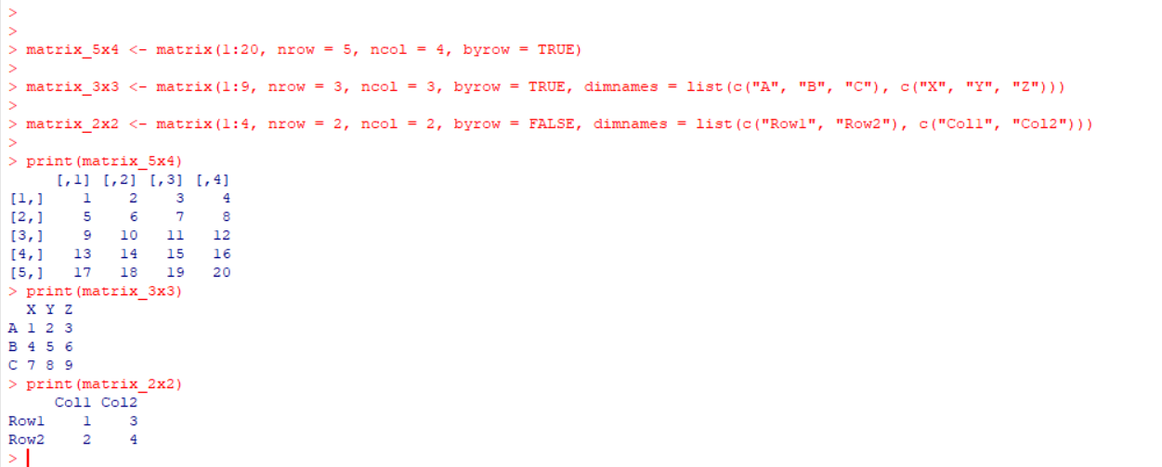

8.Write a R program to create an array, passing in a vector of values and a vector of dimensions. Also provide names for each dimension.

Output:

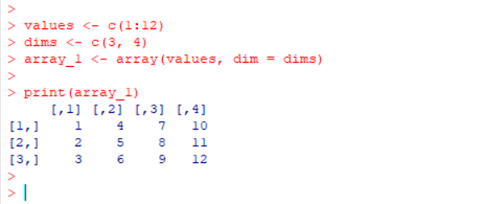

9.Write a R program to create an array with three columns, three rows, and two "tables", taking two vectors as input to the array. Print the array.

Output:

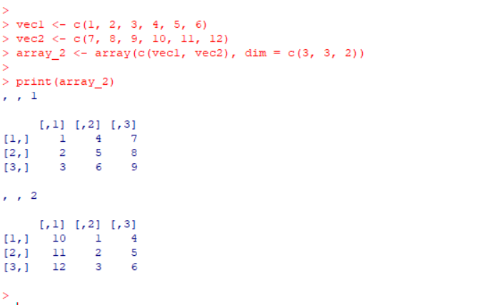

10.Write a R program to draw an empty plot and an empty plot specify the axes limits of the graphic.

Output:



